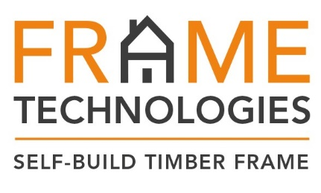
Press Release
PRESTEIGNE TIMBER FRAME MANUFACTURER GOES FOR GOLD

Specialist timber frame manufacturer, designer and supplier - Frame Technologies, has been awarded the highest possible accolade by the UK’s leading structural timber body. Under a new protocol, Frame Technologies has been the first timber frame specialist contractor to be independently audited for the Structural Timber Association’s (STA’s) Membership and Quality Standards Scheme - STA Assure. The Presteigne based company achieved Gold Status.

As the leading organisation representing the structural timber sector, the STA has recently advanced this scheme, which is designed to benefit both clients and members by promoting the differing accreditations and quality standards held by individual STA member companies. Offering reassurances to self builders and the wider construction community that members meet or even exceed current legislation and regulatory requirements – STA Assure has been upgraded from self-assessment to an independently audited scheme.

STA Assure has established three levels of membership; Gold, Silver and Bronze. The two top tiers have received formal recognition from six of the industry’s leading structural warranty and building control bodies. Manufacturing members of the STA, are put through the rigorous auditing process to ensure clients receive assurances that the company implements stringent management processes to ensure greater control over quality, productivity and predictability.

Managing Director of Frame Technologies, Simon Orrells said: “As members of the STA, we follow industry best practice and our structural timber solutions are manufactured to exacting standards in our own factory in Presteigne, Wales.

“I am very proud that Frame Technologies has achieved Gold status in the STA Assure Membership and Quality Standards Scheme. Every one of our self build project is unique, one of a kind and undeniably special. This is potentially the largest investment that our client’s will ever make and therefore, selecting their design and construction partner is a significant decision. This achievement will offer confidence to self builders who are considering using one of our systems, knowing that we have been independently audited and come out on top.”

Frame Technologies offer a wide range of timber frame services for self builders, from full supply and erect packages to supply only. With an extensive product portfolio, Frame Technologies is at the forefront of innovations in timber frame construction - delivering value, energy efficient and environmentally sound, solutions. Offering numerous benefits - timber frame construction is rapidly gaining traction within the self-build community. Speed and quality of construction, combined with improved levels of project efficiency and vast reductions in on-going running costs, are compelling benefits to influence specification decisions.
For more information on Frame Technologies, visit their website -www.frametechnologies.co.uk

[ENDS] 26 April 2018
Press Enquires
Contact Victoria Jones on 01743 290045 or Victoria.jones@radar-communications.co.uk
Notes to editor
Frame Technologies offer a wide range of timber frame services from full supply and erect packages, to supply only. With an extensive product portfolio, the company has developed structural timber systems that have the capability to exceed building regulations to deliver, if the brief demands, the ultimate performance.
By providing quality and excellence on every project, regardless of size and budget - in collaboration with self builders, Frame Technologies establishes objectives and aspirations, then consult with architects and engineers to refine these ideas into a deliverable plan.
Timber frame delivers quality and value together with enhanced performance, onsite safety, speed of construction and sustainability. As a responsible organisation, Frame Technologies are committed to sourcing timber from well managed forests with full traceability including FSC and PEFC Full Chain of Custody.

